Python with Robots  Mission 9 Lab Data Sheet – OBJ 3, 6 |  | Name:
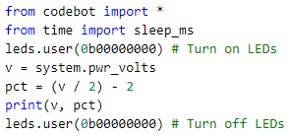
Obj. 3 Battery Tester with Load: Follow these steps:
- Start a new file and create a test program as shown ->
- Start with no LEDS turned on. Run the code.
- Check the REPL console.
- Record the battery voltage and percentage.
- Repeat, lighting another LED each time.
LEDs turned on | Voltage | Percentage
0
1
2
3
4
5
6
7
8
Obj. 6 Temperature Check: Follow these steps:
- Use your code from Objective 6
- Start with sleep_ms(200) and record the average temperature
- Repeat the experiment, changing the amount of delay. Try faster times and slower times.
- Record the average temperature for each delay.
Amount of delay | Average temperature
200

